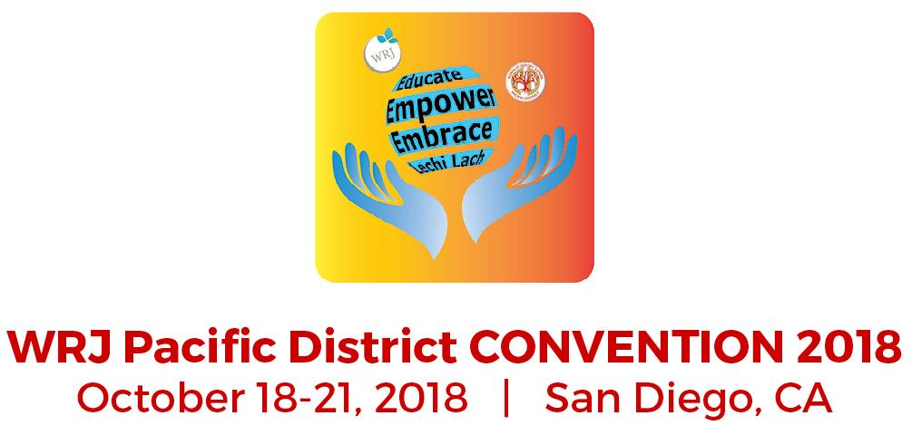
Eleanor Kretzer Kavod Award 2018 Application
Applications will be accepted between June 15 and September 25, 2018.

Applications, relevant materials, documents, and photographs must be submitted via email: kavod.wrjpd@gmail.
Each application must be submitted separately.

Congregation ________________________________ Sisterhood _________________________________
Address: __________________________________________________
City ________________________ State /Province _______ Zip/Postal Code ___________ Country __________
Contact person for Project or Program _____________________________
Telephone: _______________ Email_____________________________
I agree that the above name and e-mail may be included
in WRJ-PD publications and on the WRJ Pacific District website.
Project Information
Project or Program Category ____________________________________
Project Title: _______________________________________________
Date Presented: ________________ Date Completed: ________________ OR Ongoing: __________________
Include the following information in a description of your project or program:
- One Paragraph Synopsis of Project
- Purpose or goal
- Outcome
- Evaluation process
- Provisions made for disabilities
- Describe, when relevant, scholarships to alleviate costs, transportation considerations, unique locations
Project Involvement
- Number of members involved?
- Is number of participants adaptable? What adaptations would be needed to vary the number?
- What capacities were members involved?
- Include a list of all rabbis, temple groups, community organizations, etc. involved in the project/program and the nature of their involvement
Supporting Materials (Please review the Guidelines for Submissions to see formatting instructions for submission of supporting materials)
- Lesson or event plans
- Material lists
- Flyers, photos, handouts
- Publicity
- Additional information that would enhance or explain your entry

Questions? Please contact the Kavod committee at kavod.wrjpd@gmail

